
Database Lab
UW-24-CS-BS-101
Registration NO:
Muhammad Talha_CS.2ndB
Lab Task #7
UNIVERSITY OF WAH(UOW)

DEPARTMENT OF COMPUTER
SCIENCE

COURSE:

SUBMITTED BY:

-:LAB 7:-
FORMS
- Student

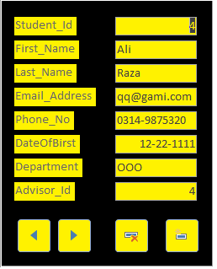
- Professor
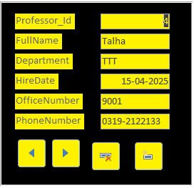

- Enrollment
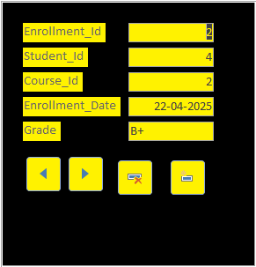

- Course
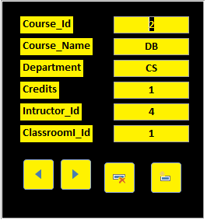

- Classroom

Table

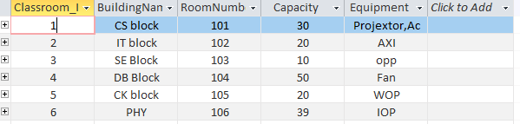
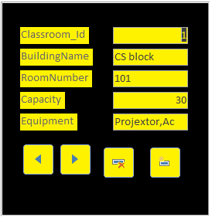
- Classroom

- Course

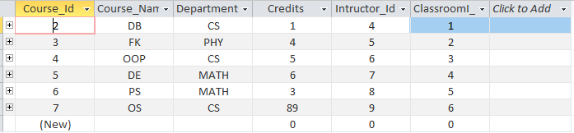

- Enrollment

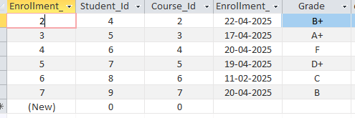

- Professor

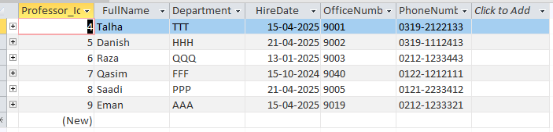
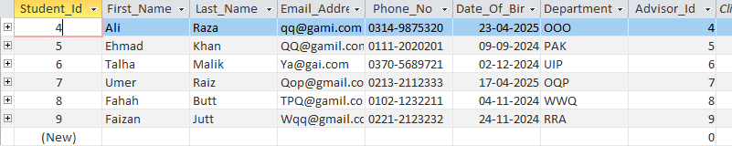
- Student

Relationship

